# Global Hazard Patterns

The three main geophysical hazards are earthquakes, volcanoes and tsunamis.

# Earthquakes:

Main earthquake zones are clustered along plate boundaries.

Our earth crust is divided into seven major sections or plates, and a number of smaller ones. Some are oceanic and some are continental. The plates float on the underlying semi-molten mantle, (asthenoshere).

There are three major types of plate boundary, constructive destructive and conservative. (Constructive and destructive = most powerful)

Hotspots from within the asthenosphere generate thermal convection currents which cause magma to rise towards the Earth’s surface. This process forms new crust along the line of constructive boundaries, where plates are diverging.

At the same time old crust is being destroyed at destructive boundaries, where plates converge. The type of activity demands on the type of plates which are meeting.

At constructive boundaries, two plates slide past each other and there is no creation or destruction of crust.

The type of movement and degree of activity at the plate margin almost totally controls the distribution, frequency and magnitude of eruptions.

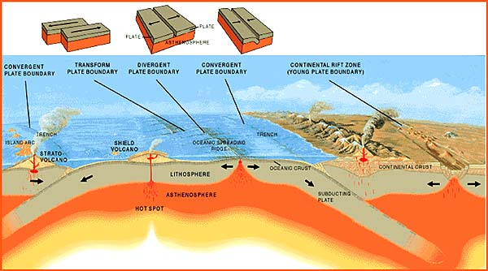

Conservative boundary: a boundary between plate where the movement of the plates is parallel to the plate margin and the plates slide past each other. Produces frequent, shallow earthquakes, sometimes of high magnitude.

Constructive boundary: a boundary between plates where the plates are diverging or moving apart. Associated with large numbers of shallow, low-magnitude earthquakes as magma rises.

Destructive boundary: a boundary between plates where the plates are converging (moving together). Causes a stress in the crust, and when released suddenly causes a violent shake above. The point where the pressure is released is called the earthquake focus. The point above the surface is called the epicentre.

Earthquake hazards:

* *Primary hazards* result from ground movement and ground shaking. Surface seismic waves can cause buildings and other infrastructure to collapse.
* *Secondary hazards* include soil liquefaction, landslides, avalanches, tsunamis and exposure to adverse weather. They can add significantly to the death toll.

Constructive plate boundaries:

Most of the magma that reaches the earth’s surface wells up at oceanic ridges such as the mid-Atlantic. These volcanoes are mostly on the sea floor and do not represent a major to people except where they emerge above sea level to form islands such as Iceland. Rift valleys occur where the continental crust is being ‘stretched’.

Destructive plate boundaries:

80% of the world’s active volcanoes occur along destructive boundaries. When oceanic plates are subducted beneath continental plates, explosive volcanoes such as Mt St Helens are formed.

# *The distribution of slides*

Include a variety of rapid mass movements, such as roc slides, debris flows, snow avalanches, rainfall and earthquake-induced landslides.

Landslides:

* Seventh biggest killer with over 1,400 deaths per year
* The most vulnerable areas are mountainous and experience landslides after abnormally heavy rain and/or seismic activity.
* Deforestation of hillsides and building on hill scopes has lead to an increase of slides.

Snow avalanches:

* Concentrated in high mountainous areas
* Suggestions that global warming may be increasing avalanche occurrences

# *The distribution of hydro-meteorological hazards*

* Widespread in distribution, growing in frequency and increasingly unpredictable in their location.

Drought:

* Over one third of the world’s land surface has some level of drought exposure. This includes 70% of the world’s people and agricultural value, which means the drought, has an effect on global-food security.
* Causes of drought include:
  + Variations in the movement of the inter-tropical convergence zone (ITCZ)(a zone of low atmospheric pressure near the equator. This migrates seasonally). S the ITCZ moves north and south through Africa, it brings a band of seasonal rain in some years; high-pressure zones expand and block the rain-bearing winds.
  + El Nino can bring major changes in rainfall patterns
  + Changes in mid-latitude depression tracks – depressions bring rainfall however if blocking anticyclones form and persist, depressions are forced to track north, leading to very dry conditions.
* Drought hazards: lead to failure of crops, loss of livestock, wildfires, dust storms and famine. Economic impacts on agriculture and water-related businesses in developed countries.

Flooding

Flooding is a frequent hazard which is evident in some 33% of the world’s area, which is inhibited by over 80% if it population.

* Causes of flooding
  + Excessive rainfall related to atmospheric processes including monsoon and cyclones.
  + Intense rainfall sometime associated with thunderstorms can lead to localised flash flooding.
  + El Nino Southern Oscillation can bring devastating floods
  + Rapid snowmelt can add water to an already swollen river system
* Flooding hazards: deaths by drowning and disease, destruction of food crops and infrastructure and loss of homes. In developed countries it disrupts transport and infrastructure, damages livelihoods and created high insurance costs.

Storms

* Include tropical cyclones, mid-latitude storms and tornados.
  + Tropical cyclones are violent storms between 200 and 700 Km in diameter. They occur in latitude 5-20 degrees north and south of the equator.
  + Tropical cyclones or hurricanes will only occur over warm ocean of at least 70m in depth at least 5o N or S of the equator in order that the Coriolis Effect can bring about rotation of air.
* Tropical storm hazards: cause hazards in several ways including heavy rain, high wind velocity and very low central pressure-they can be devastating.

# *Disaster hotpots*

Identifying and defining hazard hotspots:

Hotspots are multiple hazard zones; the level of risk was estimated by combining exposure to the six major natural hazards (earthquakes, volcanoes, land-slides, floods, drought and storms).

A project was set up to assess the risk of death and damage. By combining level of exposure, historical vulnerability, combined with potential vulnerability based on size, density and poverty of the population and GDP per unit area.

Grid squared of 2.5 minutes of latitude and longitude were used as a base for various estimates of hazard probability, occurrence and extent, and these were then related to the economic value of the land, its population and population density, and vulnerability profiles. The aim was to identify disaster as opposed to hazard hotspots, only cells with a minimum population of 1005 or densities above 5 per Km2 were entered on the database of around 4 million cells.

Managing a hazard hotspot:

The identification of multiple hazard zones has major implications for development and investment planning, and for disaster preparedness and loss prevention.

Many hazard prone areas have greater priorities such as poverty reduction, of fighting HIV/AIDS, and may be unable to afford technology required to cope with multiple hazards.